***Project Report***

***On***

**Weather Station using IOT**

**Submitted for the requirement of**

**Project**

BACHELOR OF ENGINEERING

**COMPUTER SCIENCE & ENGINEERING**



**Submitted to: Submitted By:**

**Charanpreet Ma’am NAME: Mishra Nitin Sherbahadur**

**UID: 18BCS1988**

**Name: Dhruv Bhattacharjee**

**UID:18BCS2072**

**Mentor Signature**

**DEPARTMENT OF COMPUTER SCIENCE & ENGINEERING**

**CHANDIGARH UNIVERSITY, GHARUAN**

**June 2021**

**IMPLEMENTATION:**

The implementation is now been achieved till 70-80% of the main project. As our project

contains both software and hardware element following is list of hardware components and

technologies used to implement the logic.

**Hardware:**

* Arduino Uno Board
* ESP8266 WIFI module
* Raindrop sensor
* DHT11 Temperature and Humidity sensor
* Servo Motor

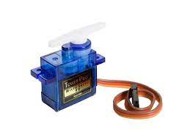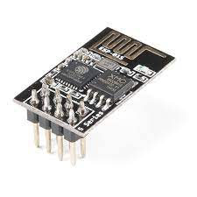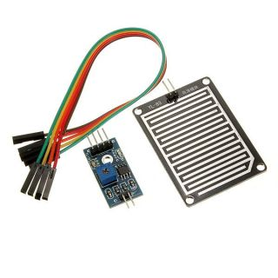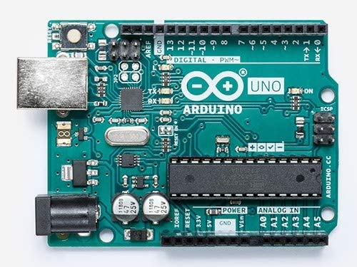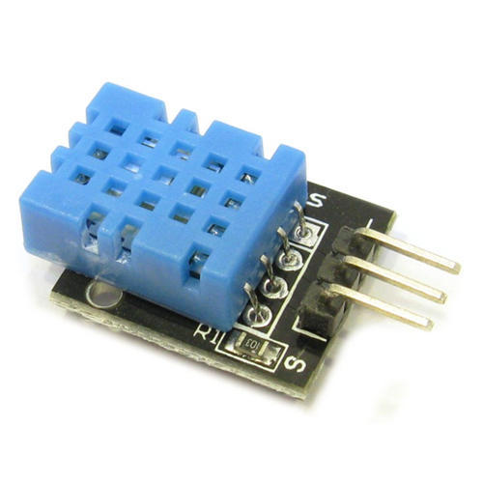

**Software technologies:**

* NodeJS
* JavaScript
* MongoDB
* React
* MQTT protocol
* Mosquitto MQTT broker
* Arduino IDE
* HTML
* CSS
* Python

On the hardware part, the Arduino board gathers temperature, humidity, GPS coordinates,

rain data from all sensors attached to it and then send it over to MQTT broker running on

server. As the broker receives the NodeJS module also running on same server collects that

data stores it in database which also running on the same server. The reason MongoDB is

chosen is that it provides JavaScript library which makes it very easy to communicate with

Database.

For the frontend we have used React, a JavaScript library created and maintained

by Facebook.

**Step by step process:**

1. Arduino publishes the data to network through MQTT protocol.
2. The JavaScript code running on the same network subscribes to topic collects the data published by Arduino.
3. The same program which collects the data stores the data in the database by using *‘mongodb’* library.
4. The collected data can now be viewed through webpage served on same network.

**Hardware configuration:**

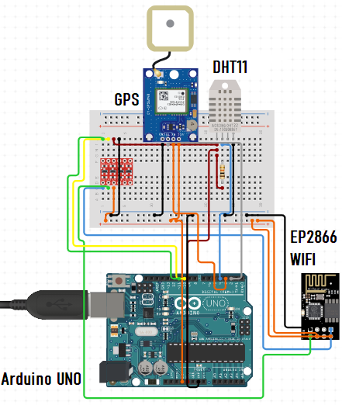

**Hardware Configuration**

Above is the diagram of our system. Here a Arduino Uno board is connected to different

sensors and modules like DHT11, Raindrop Sensor, GPS sensor and ESP8266 WIFI module.

Arduino Uno has inbuilt WIFI capabilities so we have made use of ESP8266 to connect

Arduino board to network through which it will transmit the data. ESP8266 is a WIFI micro-

Controller which can work in combination with Arduino uno or can also be used standalone

device. The temperature and humidity are both collected by DHT11, a very reliable low-cost

and accurate sensor for its purpose. The raindrop sensor is a very simple sensor which detects

raindrop droplets in order to check for rain, Ublox-6 is GPS sensor which collects GPS

coordinates of the place at which the device is placed. The overall power consumption of the

device is very low and can run on a very simple battery for long time or can also be powered

through a DC adapter.

**Software Configuration:**

Arduino code:

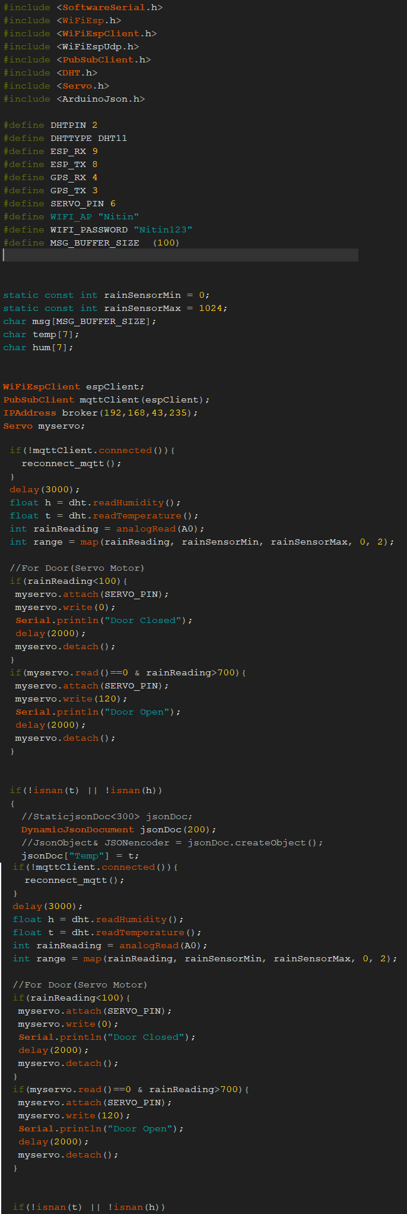

**Arduino Code.**

Above is a part of code that runs on Arduino board and send all data.This code is implemented to program the working of the sensors and also connection to MQTT to mosquitto server.

NodeJS code to collect and store data:

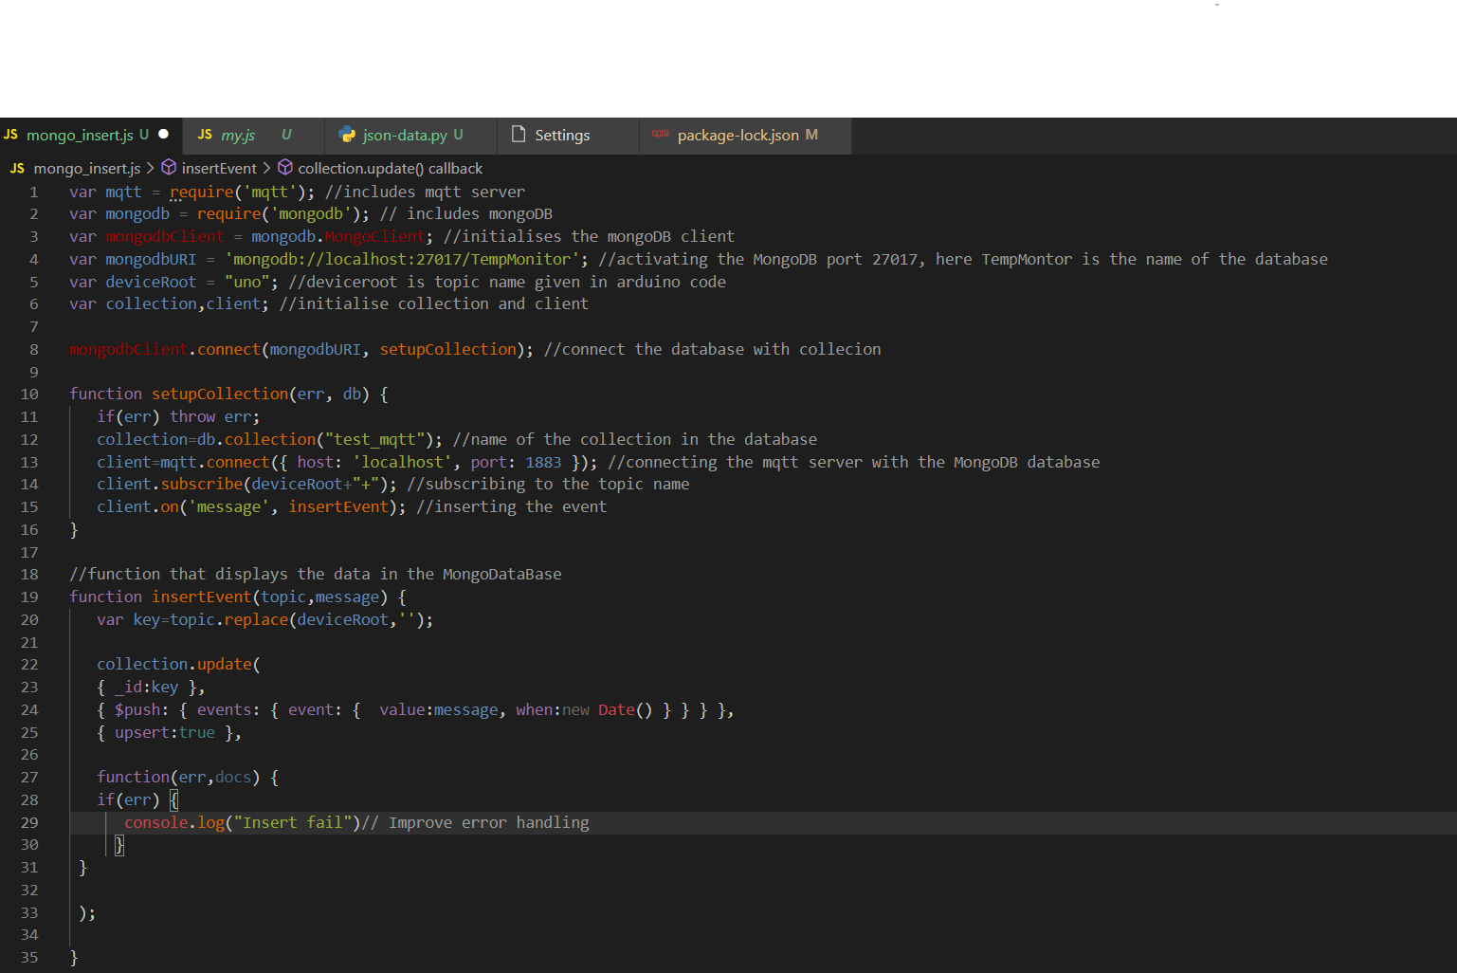

Here the data is been extracted by the MQTT through mosquitto and stored in MongoDB

The Data is stored in JSON format.

**Frontend:**

Homepage:

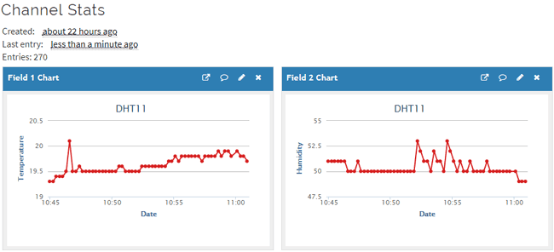

**Homepage.**

This is the current layout of homepage which display the chart of temperature and humidity

over time. It fetches data from the database created on local server as it get updated. Right

now this the only page on website but more pages and graphs are going to be added as we

keep working on it.

The frontend is made using react.

**TEAM WORK:**

The Team distribution and workload distribution during this development process has been given below.

**Mishra Nitin Sherbahadur 18BCS1988**

As the only member in the team all the things are created by me which includes:

* Configuring hardware.
* Arduino logic coding
* NodeJS server
* Creating database

**Dhruv Bhattacharjee 18BCS2072**

* Frontend development.

**CONCLUSION:**

Making this project has improved and hugely expanded my skill set. I got to learn about

many new technologies. I learned JavaScript and NodeJS for the purpose of development of

this project. I learned how to create webpages in react. And as I keep working on it I intend

to create weather prediction of place from the collected data. Also a android app is to created

so that the data can be easily viewed from mobile devices.